Curriculum Web Service Runbook

Description:

The curriculum web service is a website that is used to look up information on CSUN courses and classes being offered.

Required Software:

AWS Account

Terraform

AWS CLI

GIT and GITHUB

Ansible

Python

SSH

Architecture Diagram:

INTERNET

WEBSERVER_C

WEBSERVER_B

NAT GATEWAY

ELB

BASTION

INTERNET GATEWAY

DEPLOYMENT:

1. We begin by first creating an AWS account. All of our instances will run on AWS.
2. Next, create a Github account. We will push our code on to github, an open source project where we will store our code. Also download git on to your machine.
3. Next step is to begin creating the infrastuture code that will create and run the three instance: Bastion, webserver_b, and webserver_c. We will use terraform.
4. Now we will download Terraform. You should find the Terraform download that complies with your operating system.
5. When infrastructure code is done run command *terraform plan* then *terraform apply*” to apply the changes and push them on to AWS.



1. Next, we need to download ansible on to our machine.

I use MAC OS X so I run *sudo pip install ansible.*

1. Now, download the git repo from [f16-cit360/cit-360](https://github.com/f16-cit360/cit-360). Simply run *git clone https://github.com/f16-cit360/cit-360.git.* This makes a copy the files that are on that folder.
2. Next step is to configure and modify the playbooks (db.yml and web.yml) to run services on to the localhost instance (bastion) and on to the webservers.
3. Push your code on to your github repo when the playbooks are ready.
4. When the infrastructure is up and running, should connect to the Bastion Instance using ssh.

In order to connect to mine, I run ***ssh -i "cit360.pem"*** [***ec2-user@35.160.51.117***](mailto:ec2-user@35.160.51.117)***.***

1. When inside the bastion instance, we need to download ansible and git once more on here. We also need to clone our OWN git repo to download the ansible playbooks.
2. First we run the db.yml playbook. The command is *ansible-playbook –i hosts.ini db.yml –ask-vault-pass*

If there are no errors. The end should look like this:



1. Next we run the web.yml playbook. It should look like this when done:

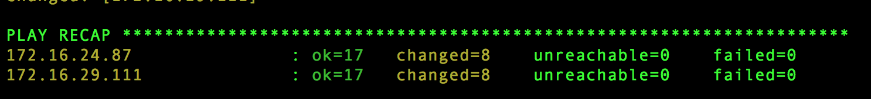

1. If everything is working, you will be able to see the webservers page using the public DNS name of your ELB created. Mine is: *elb-1481301559.us-west-2.elb.amazonaws.com*

The end result should look like this:

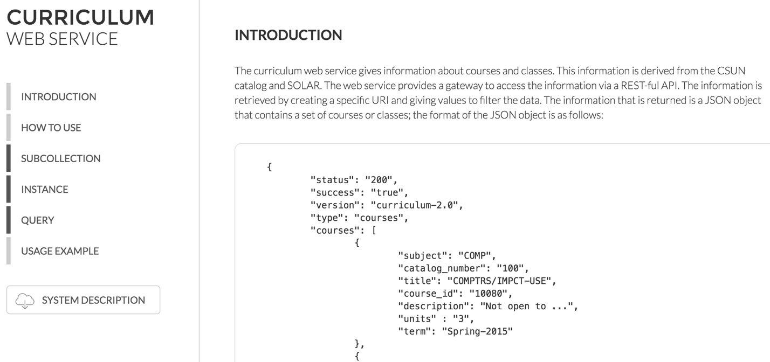

Issues:

1. Many Issues may arise while doing this project. MANY. The most common ones that I saw where connecting to the Bastion Instance. The fix is easy. The terraform documentation provides all of the necessary fields to create the correct security group that will allow you to ssh into the machine.
2. Another issue I was having was encrypting my secret.yml. Make sure the file is encrypted correctly and that you are using the same password for the db.
3. Subnetting is important. When creating the 3 public and 3 private subnets make sure that you allocate the correct number of address to each subnet or else the infra.tf file will run into some errors.

Created by: Evelin Araujo

Github repo: evarmentaa